# Results

**3.1 PVA124-TA hydrogels with different TA concentrations**

PVA124-TA hydrogels were prepared with different concentrations of TA (Fig.1). When TA concentration was 0wt%, PVA124 hydrogel had good transparency but poor mechanical strength. When 0.625wt%TA was added, the transparency of PVA124-TA hydrogel decreased, but the mechanical property was improved. When 1.25wt%TA was added, the transparency was further decreased and the mechanical property was further improved due to the increase of TA content. With the addition of 2.5wt%TA, the hydrogel was stratified.

1. **c**

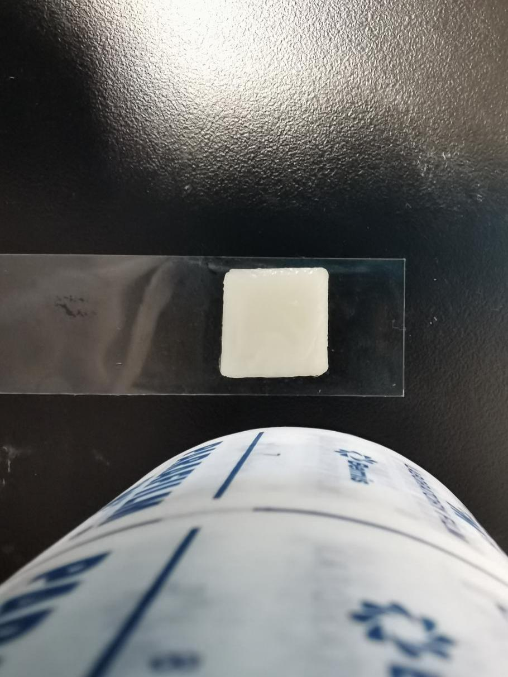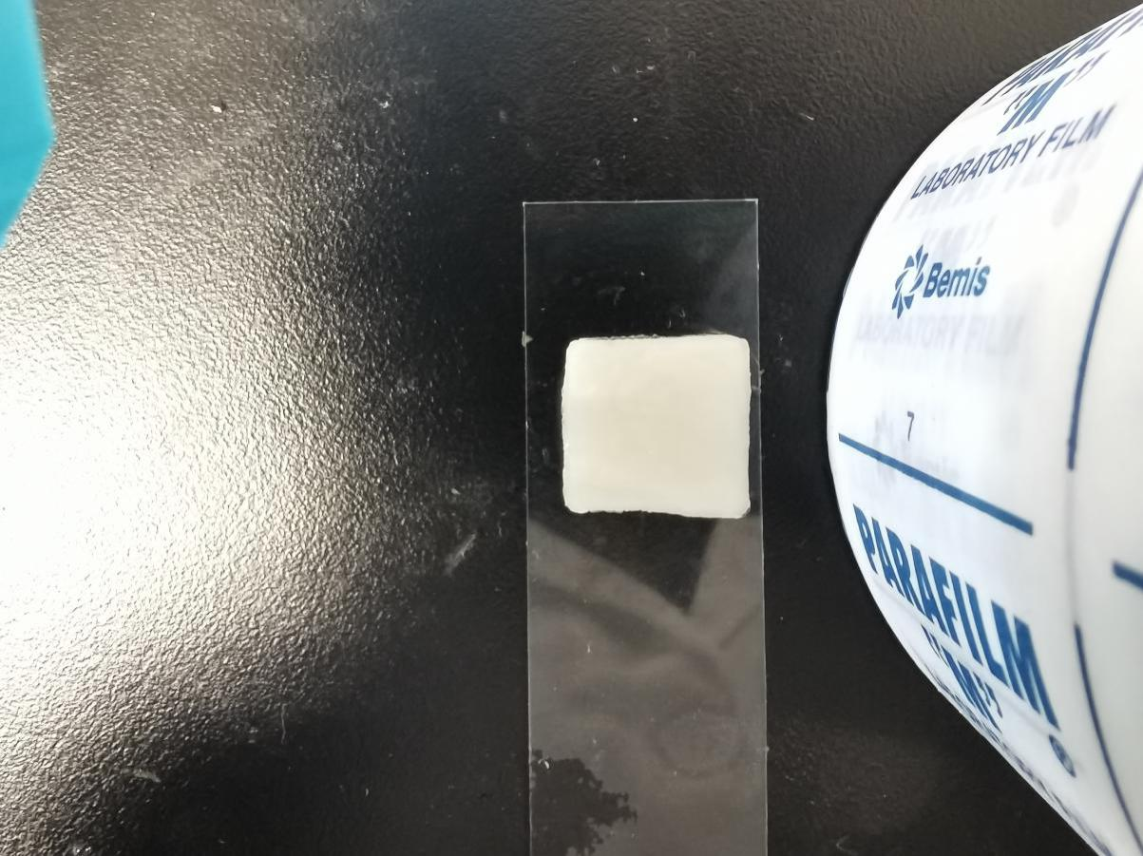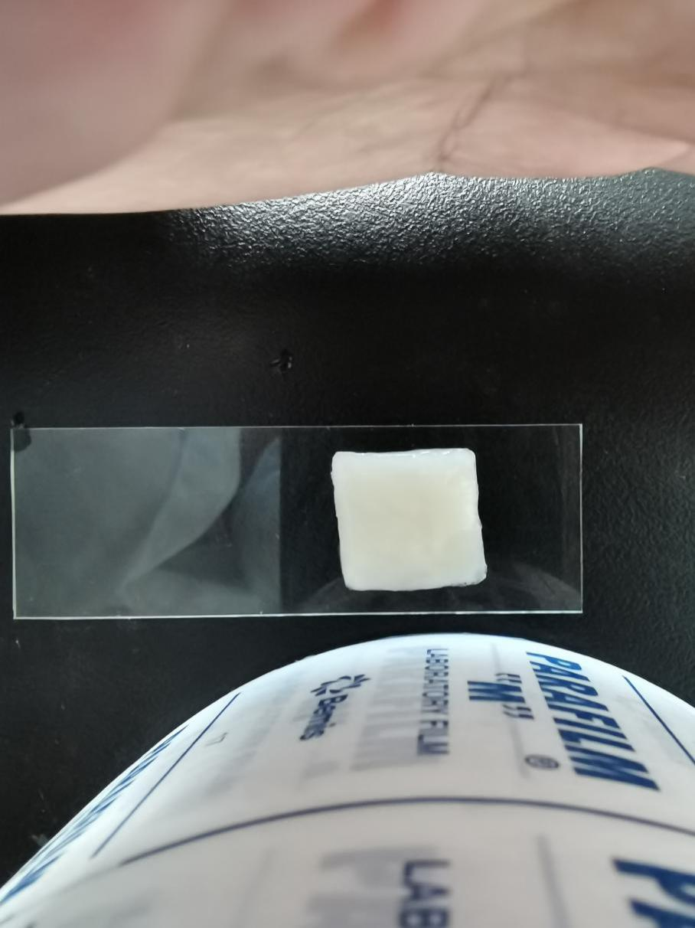

1. **d**

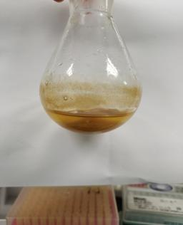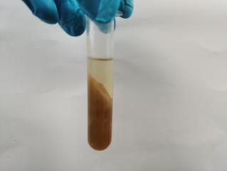

1. **a**

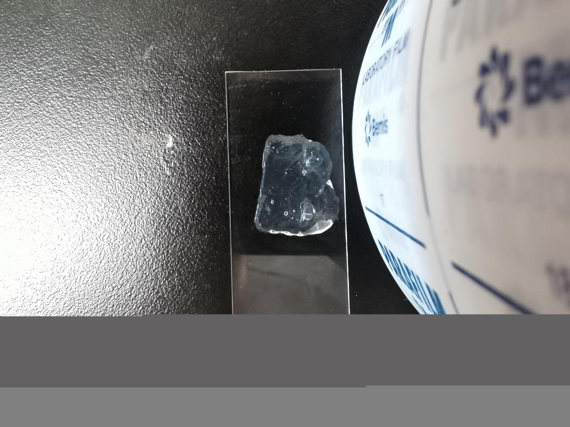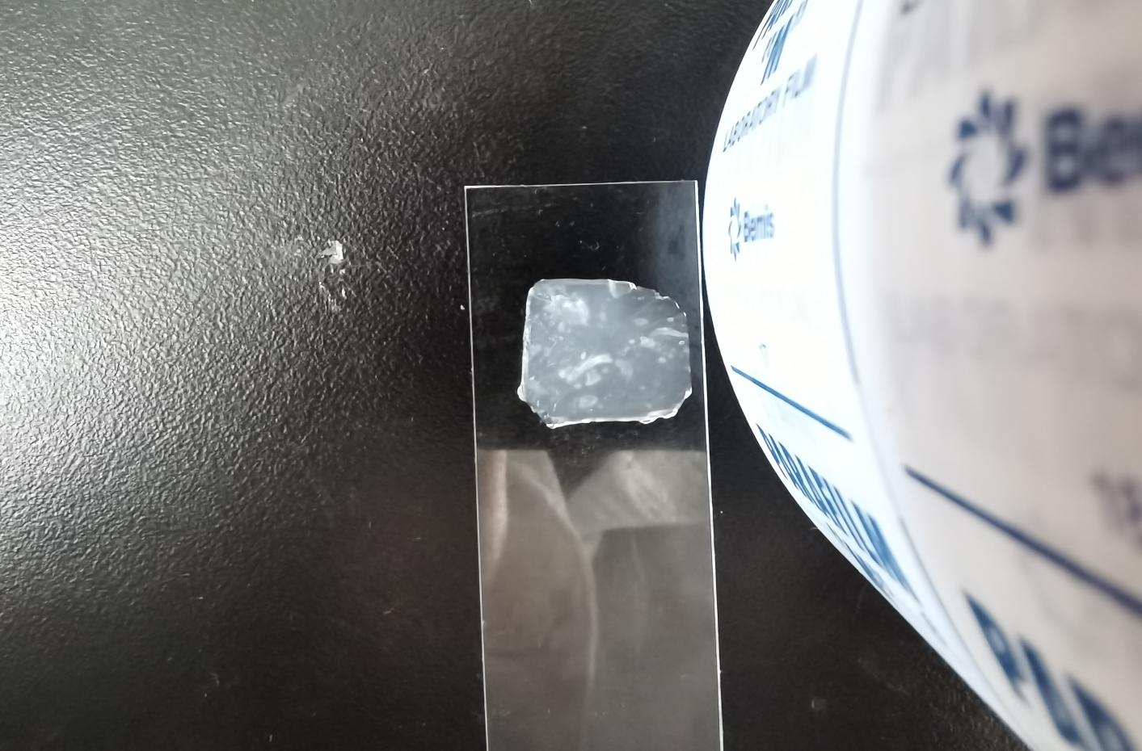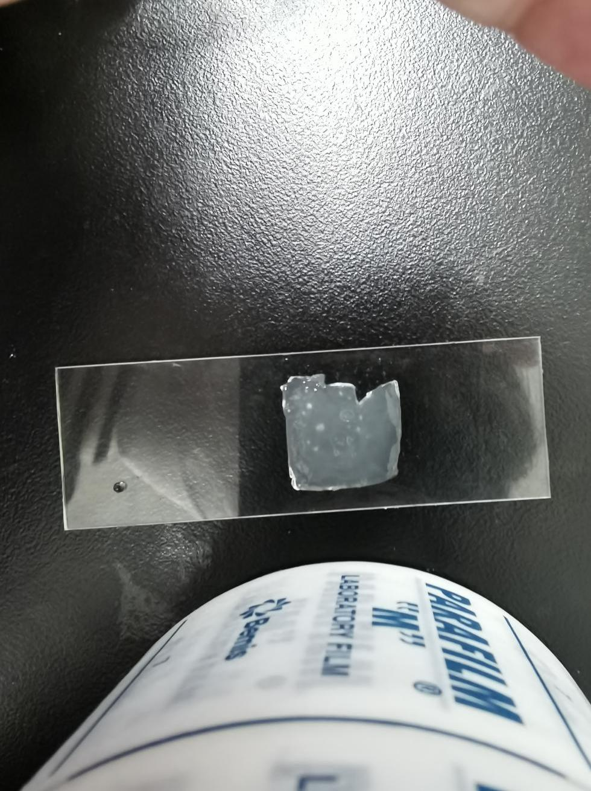

1. **b**

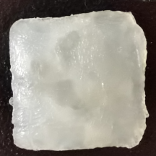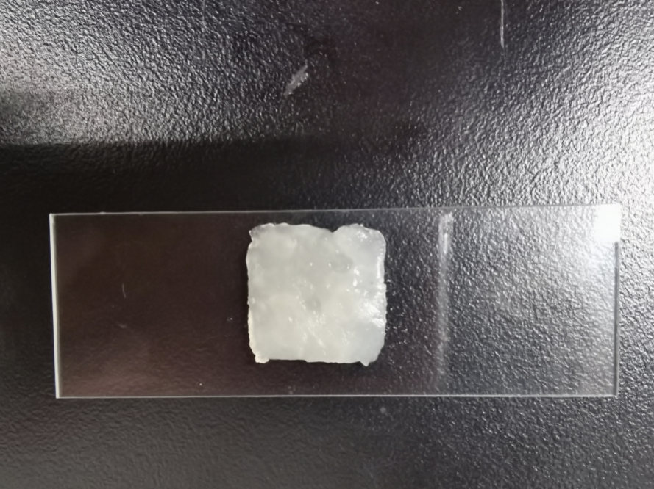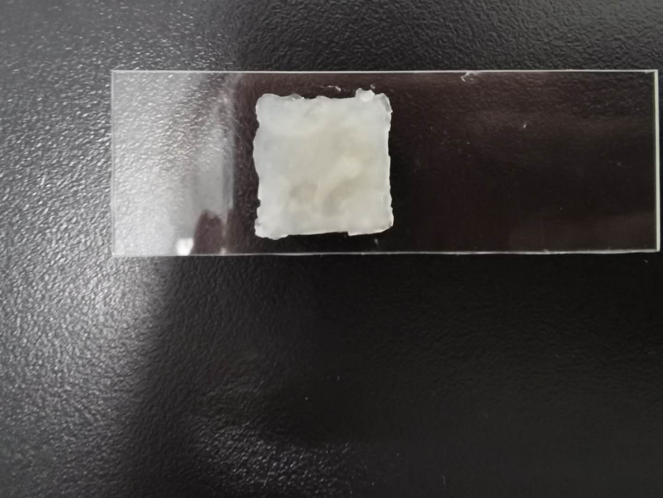

Figure 1. PVA124-TA hydrogel with different TA concentrations. From a to d, the content of TA was 0wt%, 0.625wt%, 1.25wt%, 2.5wt%, respectively.

**3.2 Antioxidant property**

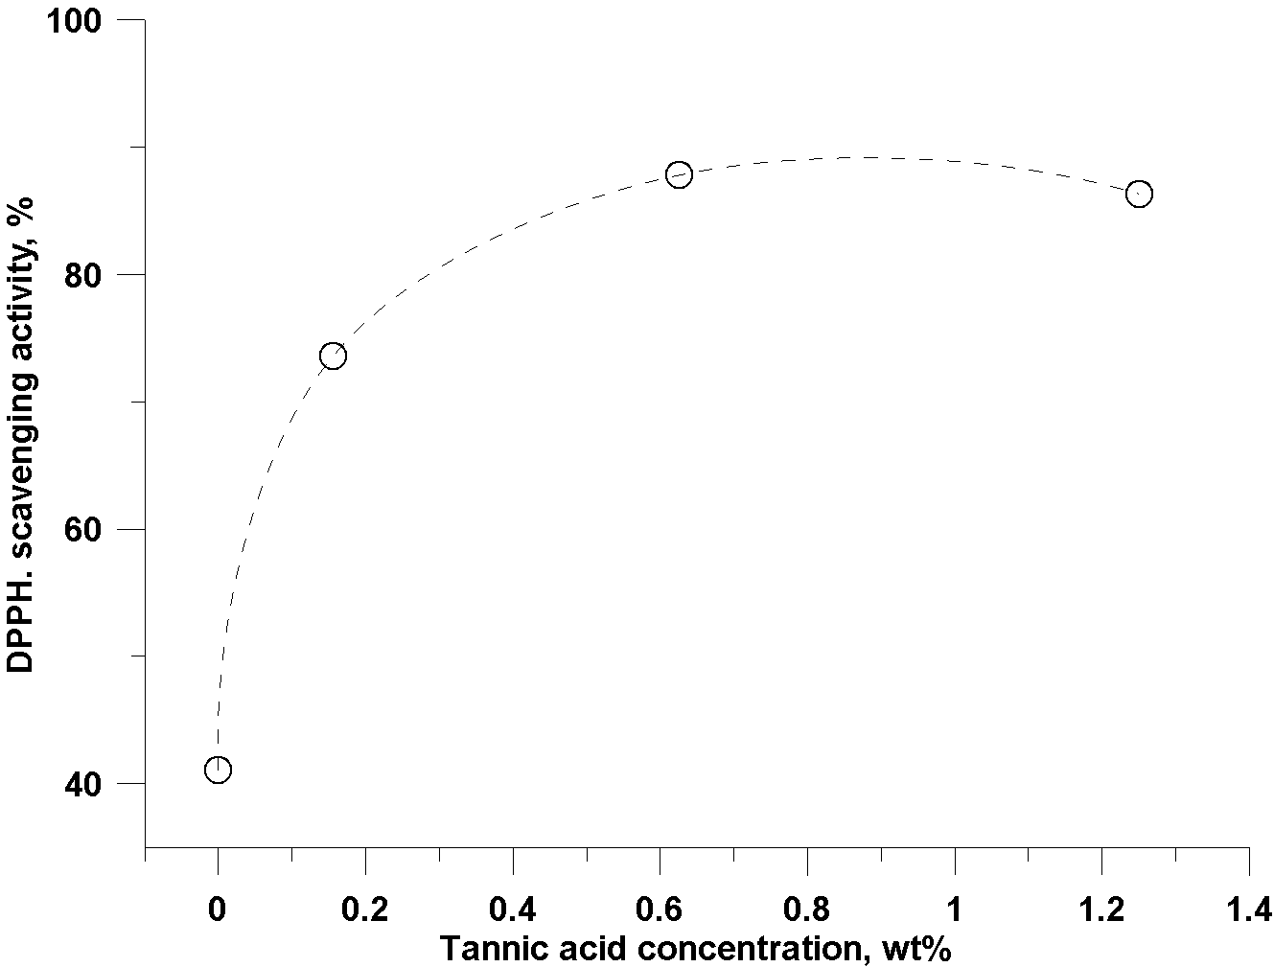The antioxidant property of PVA124-TA hydrogel was measured by DPPH method. The antioxidant capacity of PVA124-TA hydrogel increased with the increase of TA concentration in hydrogel, reaching the maximum (87.9%) when TA concentration was 0.625wt%), and then decreased slightly (Fig.2). Therefore, the most suitable concentration for TA was 0.625wt% when preparing PVA124-TA hydrogel by freeze-thawing method.

Figure 2. The effect of TA concentrations on the antioxidant property of PVA124-TA hydrogel.

**3.3 Mechanical property of PVA124-TA (0.625wt%) hydrogel**

The tensile strength of PVA124-TA hydrogel was within the range of 62-178 kPa, and the elongation at break was between 217% and 376% (Fig.3). With the increase of freezing-thawing times, the tensile strength of PVA124-TA hydrogel was increased while the elongation at break was decreased. Compared with the PVA124-TA hydrogel which was freeze-thawing for once, the tensile strength of PVA124-TA hydrogel which was freeze-thawing for twice was about 2.4 times higher and the elongation at break was about 29.3% lower, which was more suitable for wound dressings. Thus, PVA124-TA (0.625wt%) hydrogel prepared with twice freeze-thawing cycles has moderate tensile properties and tensile strength.

The adhesion ability of PVA124-TA(0.625wt%) hydrogel on glass, wood, polypropylene, brass alloy and other substrates with different freezing-thawing times is shown in Figure 4. As the increase of freezing-thawing times, the adhesion of PVA124-TA (0.625%) hydrogel on some substrates was decreased or even disappeared.

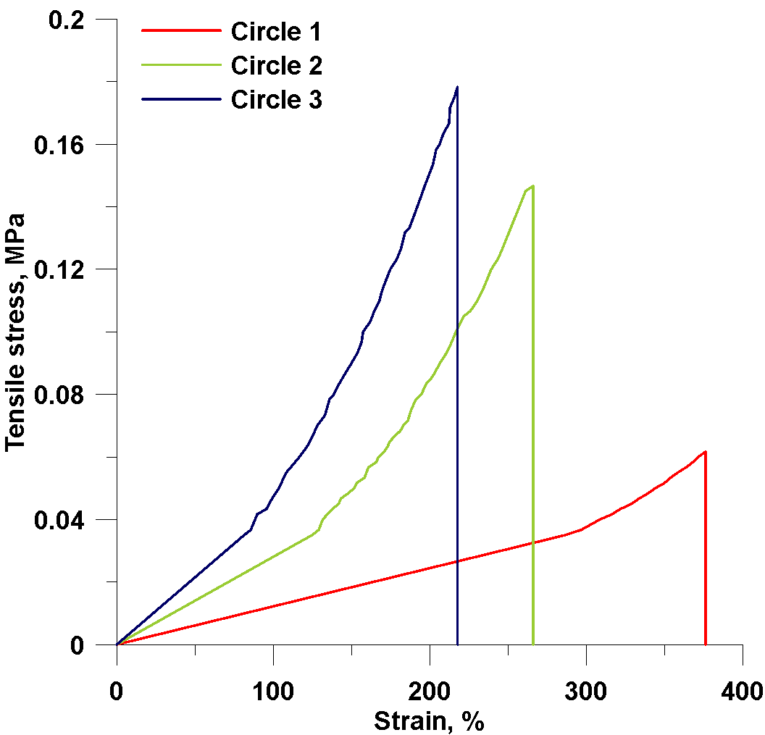

Figure 3. Mechanical property of PVA124-TA (0.625wt%) hydrogel with different freeze-thawing times.

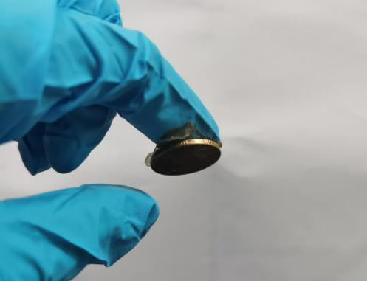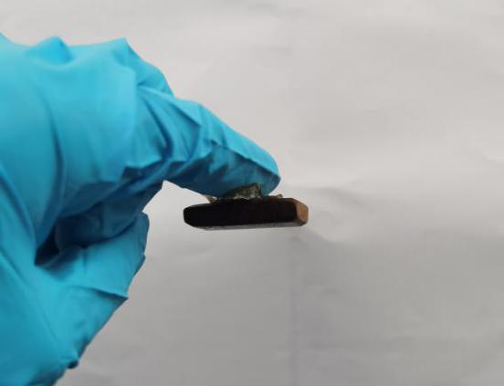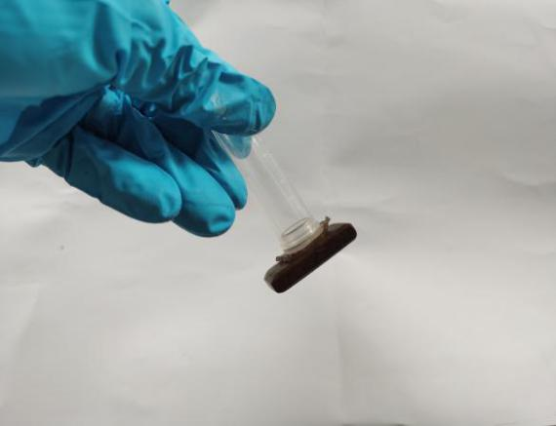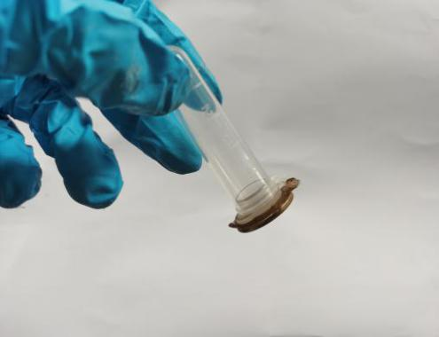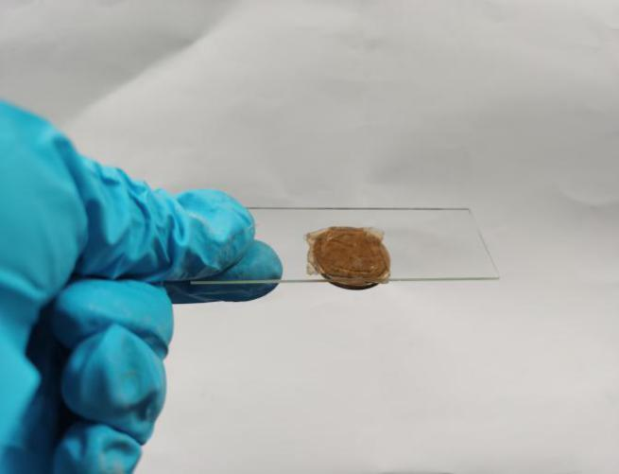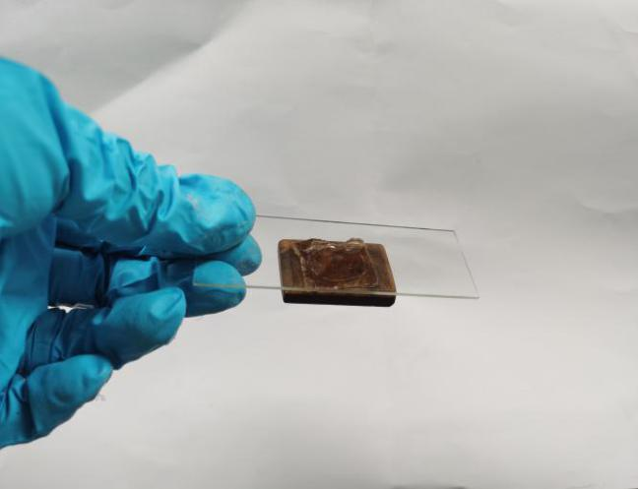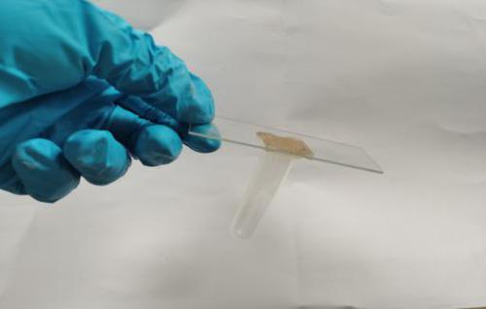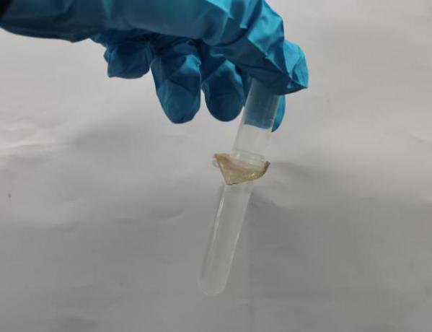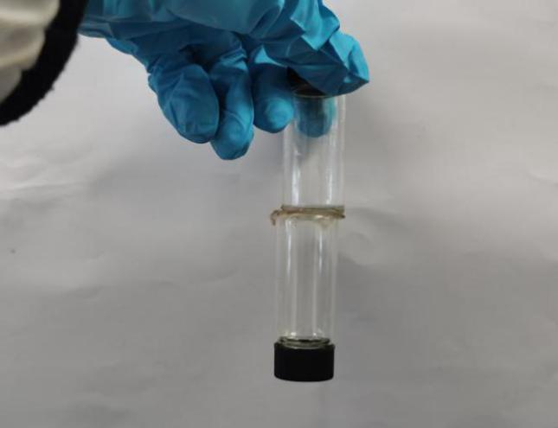

**a**

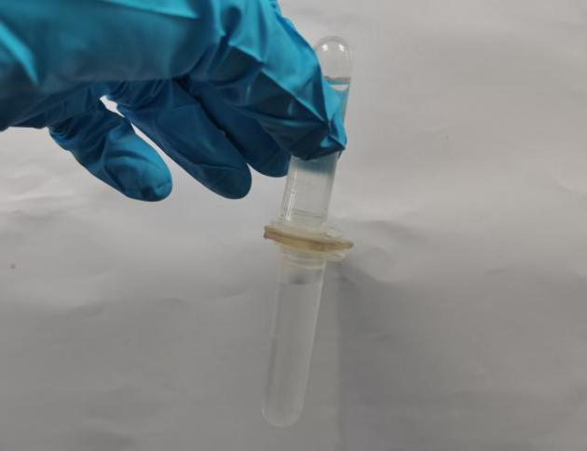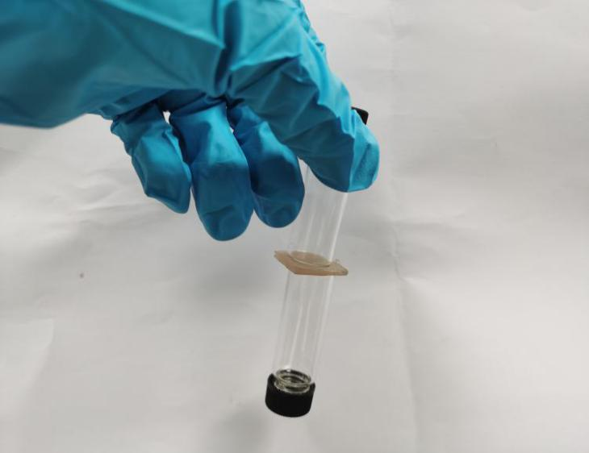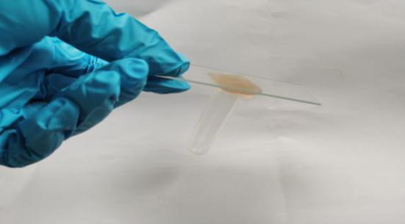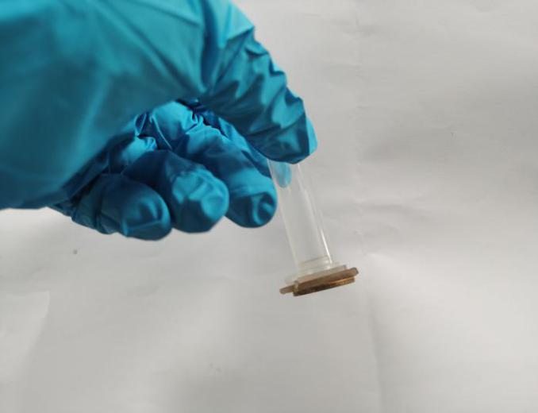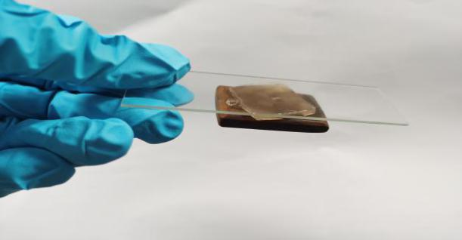

**b**

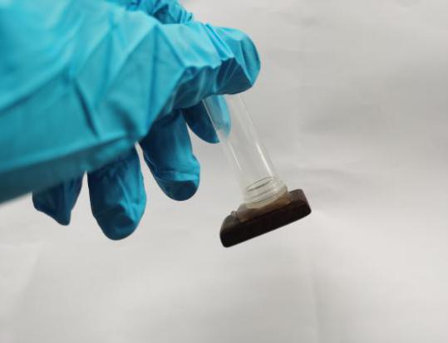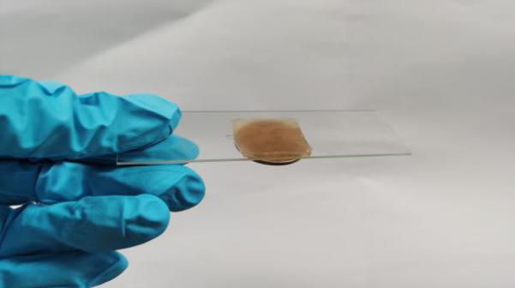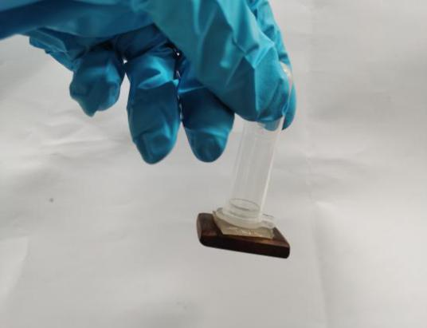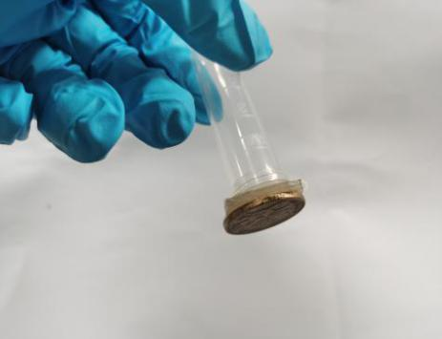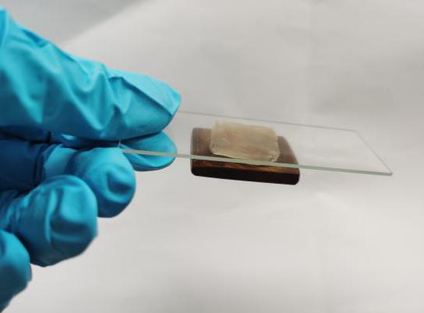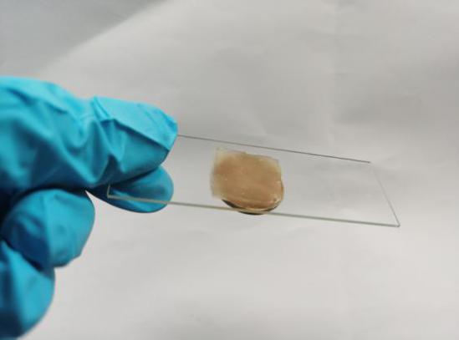

**c**

Figure 4. Adhesion of PVA124-TA (0.625%) hydrogel to different substrates with different times of freeze-thawing. (a) once freeze-thawing, (b) twice freeze-thawing and (c) three times freeze-thawing.